Payette and Fruitland United Methodist Churches
December 27, 2020
First Sunday after Christmas

Prelude

Welcome

Interlude

Welcoming the neighborhood to worship
Call To Worship:
Carol Angels from the Realms of Glory UMH #220

Angels from the realms of glory,
wing your flight o’er all the earth;
ye who sang creations story now proclaim Messiah’s birth:

Refrain
Come and worship, come and worship,
worship Christ, the newborn King.

Saints, before the altar bending,
watching long in hope and fear;
suddenly the Lord, descending, in his temple shall appear:

Refrain

Reading from Psalm 148:1-4 (TNIV)
Leader: Praise the Lord from the heavens;
People: praise him in the heights above!
Leader: Praise him, all his angels;
People: praise him, all his heavenly hosts!
Leader: Praise him, sun, and moon;
People: praise him, all you shining stars!
All: Praise him, you highest heavens!

Unison Invocation UMH #231
Eternal God,
by the birth of Jesus Christ you gave yourself to the world. Grant that, being born in our hearts,
he may save us from all our sins,
and restore within us the image and likeness of You,
our heavenly Father,
to whom be everlasting praise and glory.
Amen.

Carol The First Noel UMH #245
The first Noel the angel did say
was to certain poor shepherds in fields as they lay;
In fields where they lay keeping their sheep,
on a cold winder’s night that was so deep.

Refrain
Noel, Noel, Noel, Noel,
Born is the King of Israel.

They looked up and saw a star shining in the east,
beyond them far; and to the earth it gave great light,
and so it continued both day and night.

Refrain

New Testament Reading Galatians 4:4-7
God’s Word for God’s people
Thanks be to God

Message “He Was Named Jesus” Luke 2:22-40

Carol O Come, All Ye Faithful UMH #234

O come, all ye faithful, joyful and triumphant,
O come, ye, O come ye, to Bethlehem.
Come and behold him, born the King of angels;

Refrain
O come, let us adore him,
O come, let us adore him.
O come, let us adore him,
Christ the Lord!

Sing, choirs of angels, sing in exaltation;
O sing, all ye citizens of heaven above!
Glory to God, all glory in the highest;

Refrain
.
Benediction
May the peace of the Lord Jesus go with you
wherever he may send you.
May he guide you through the wilderness,
protect you through the storm.
May he bring you home rejoicing
at the wonders he has shown you.
May he bring you home rejoicing once again into our doors.

Postlude

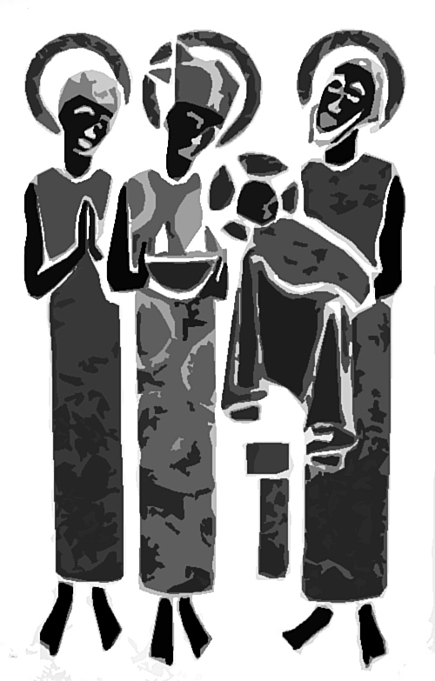

(CCLI License #1552544)

