Fruitland and Payette United Methodist Churches
December 20, 2020
Fourth Sunday of Advent

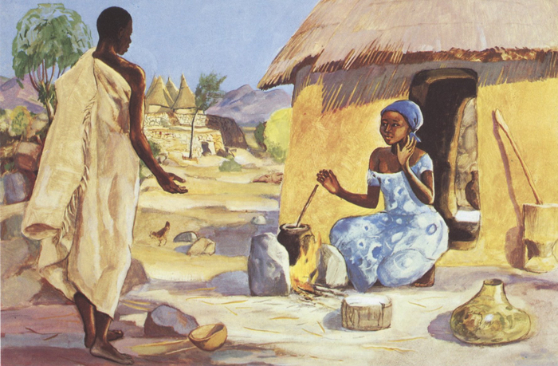

Prelude Away in a Manger arr. Phillip Keveren

Solo: Jim Trenkel

Welcome

Interlude Joy to the World Arr. Gilbert Martin

Welcoming the neighborhood to worship
Call To Worship:
Carol He Came Down TFWS #2085
He came down that we may have hope;
He came down that we may have hope;
He came down that we may have hope;
Hallelujah for evermore.

He came down that we may have love…

He came down that we have joy…

He came down that we have peace…

Reading from Psalm 89:1-5 (TNIV)
Leader: I will sing of the Lord’s great love forever; with my mouth will I make your faithfulness known.
People: I will declare that your love stands firm forever, that you have established faithfulness in heaven itself.
Leader: You said, “I have made a covenant with my chosen one, have sworn to David my servant, I will establish your line forever and make your throne firm through all generations.”
People: The heavens praise your wonders, Lord.
All: For who in the skies above can compare with the Lord?

Unison Invocation
Thank you, Lord,
for the signs that confirm that your kingdom
will always overwhelm darkness and evil
even when those plans involves people and situations
we would never choose.
Come, Lord Jesus, Come.
Amen.

Carol It Came upon the Midnight Clear UMH #2182

It came upon the midnight clear,
that glorious song of old,
from angels bending near the earth,
to touch their harps of gold;
“Peace on the earth, good will to men,
from heaven’s all gracious King.”
The world in solemn stillness lay,
to hear the angel’s sing.

For lo! The days are hastening on,
by prophets seen of old,
when with the ever circling years
shall come the time foretold
when peace shall over all the earth
its ancient splendors fling,
and the whole world send back the song
which now the angles sing.

Prayers of the People

Gospel Reading Luke 1:46-55
God’s Word for God’s people
Thanks be to God

Message “The Lord is With You” Luke 1:26-38

Chorus Let There Be Peace UMH #431

Let there be peace on earth and let it begin with me;
let there be peace on earth, the peace that was meant to be. With God as our Father, children all are we.
Let us walk with each other in perfect harmony.
Let peace begin with me; let this be the moment now.
With every step I take, let this be my solemn vow;
to take each moment and live each moment
in peace eternally.
Let there be peace on earth, and let it begin with me.

Benediction
May the peace of the Lord Jesus go with you
wherever he may send you.
May he guide you through the wilderness,
protect you through the storm.
May he bring you home rejoicing
at the wonders he has shown you.
May he bring you home rejoicing once again into our doors

Postlude Carol Fantasy arr. Gilbert Martin

(CCLI License #1552544)

