Fruitland and Payette United Methodist Churches
January 10, 2021
First Sunday after Epiphany

Prelude

Shall We Gather at the River/On Jordan’s Stormy Banks I Stand
African-American Spirituals arranged by Glenda Austin

Welcome

Interlude Deep River arranged by Ethel Smith

Welcoming the neighborhood to worship
Call To Worship:
Reading from Psalm 29
Leader: Praise the Lord, you angels in heaven. Praise the Lord for his glory and strength.
People: Praise the Lord for the glory that belongs to him. Worship the Lord because of his beauty and holiness.
Leader: The Lord rules from his throne as King forever.
People: The Lord give strength to his people.
All: The Lord blesses his people with peace.

Calling Song
O come, all ye faithful, joyful and triumphant,
O come, ye, O come ye, to Bethlehem.
Come and behold him, born the King of angels;
Refrain
O come, let us adore him,
O come, let us adore him.
O come, let us adore him,
Christ the Lord!

For he alone is worthy.
For he alone is worthy.
For he alone is worthy.
Christ the Lord!

Unison Invocation
Eternal God,
We know that you do not exist to answer our prayers.
Please forgive us when we act differently.
But we are needy people. Needy for you.
Inspire us with the fire of your Spirit
to join in the transforming work of Jesus.
We ask this in his name.
Amen.

Old Testament Reading Genesis 1:1-5
Gospel Reading Mark 1:4-11
God’s Word for God’s people
Thanks be to God

Prayers of the People

Hymn On Jordan’s Stormy Banks UMH #724
On Jordan's stormy banks I stand,
and cast a wishful eye
to Canaan's fair and happy land,
where my possessions lie.
Refrain:
I am bound for the promised land,
I am bound for the promised land;
oh, who will come and go with me?
I am bound for the promised land.
No chilling winds or poisonous breath
can reach that healthful shore;
sickness and sorrow, pain and death,
are felt and feared no more. [Refrain]
When I shall reach that happy place,
I'll be forever blest,
for I shall see my Father's face,
and in his bosom rest. [Refrain]

Message “They Invited Him” Acts 19:1-7

Commitment Hymn Amazing Grace UMH #

Benediction
May the peace of the Lord Jesus go with you
wherever he may send you.
May he guide you through the wilderness,
protect you through the storm.
May he bring you home rejoicing
at the wonders he has shown you.
May he bring you home rejoicing once again into our doors.

Postlude Wade in the Water arranged by Dan Fox

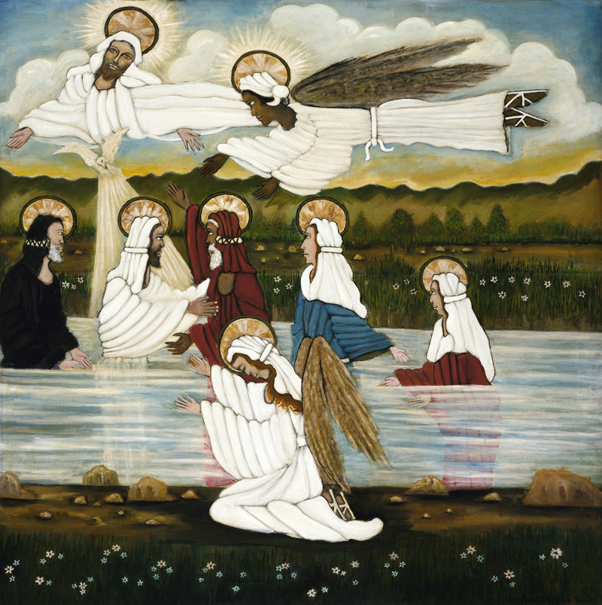
Lorenzo Scott - 1987

(CCLI License #1552544)

