Fruitland and Payette United Methodist Churches
March 7, 2021
Third Sunday of Lent – Holy Communion
Prelude: In the cross of Christ I glory, Rathbun tune arr. Larry Shackley

Welcome
Welcoming the Light of Christ – please light a candle
Interlude: The old Rugged Cross by George Bennard

Inviting the neighborhood to worship
Call to Worship:
Calling Song I Come with Joy UMH #617
I come with joy to meet my Lord,
forgiven, loved and free,
in awe and wonder to recall
his life laid down for me,
his life laid down for me.
And thus with joy we meet our Lord,
His presence always near,
is in such friendship better known;
we see and praise him here,
we see and praise him here.

The Apostles Creed
I believe in God, the Father Almighty, creator of heaven and earth.
I believe in Jesus Christ, his only Son, our Lord,
who was conceived by the Holy Spirit,
born of the Virgin Mary,
suffered under Pontius Pilate,
was crucified, died, and was buried;
he descended to the dead.
On the third day he rose again;
he ascended into heaven,
is seated at the right hand of the Father,
and will come again to judge the living and the dead.
I believe in the Holy Spirit,
the holy universal church,
the communion of saints,
the forgiveness of sins,
the resurrection of the body,
and life everlasting.
Unison Invocation
O God our Father, who sent your Son to be King of kings
and Lord of lords;
we pray that all the kingdoms of this world
may become His kingdom
and learn from him the way of grace and truth.
In His name we pray. Amen.

Old Testament Reading Exodus 20:1-17

New Testament Reading 1 Corinthians 1:18-25
Message “He Knew what was In them” John 2:13-25

The Communion Service

Communion Hymn Turn Your Eyes upon Jesus

O soul, are you weary and troubled;
No light in the darkness you see?
There’s light for a look at the Savior
And life more abundant and free.

(Refrain) Turn your eyes upon Jesus.
Look full in his wonderful face.

And the things of earth will grow strangely dim
in the light of his glory and grace.

Through death into life everlasting
He passed and we follow him there.
Over us sin no more has dominion
For more than conquerors we are! Turn your eyes . . .

Our Lord invites to his table all who love him,
Who earnestly repent of their sin and seek to live in peace with one another.
Let us confess our sin before God and one another.

Prayer of Confession and Pardon
Merciful God, we confess that we have not loved you with our whole heart.
Our faith has been tested and we have stumbled.
Our feet have strayed from the path of Christ and we have wandered from you.
We have put our faith in the loud voices of this world, ignoring your whispers.
Forgive us, we pray.
We do want to follow Jesus, the Christ, in whose name we pray. Amen.

Hear the good news;
Christ died for us while we were yet sinners. That proves God’s love for us.
In the name of Jesus Christ, you are forgiven.

In the name of Jesus Christ, you are forgiven.
Thanks be to God!
Bread and Cup
Please take the bread.
Please take the cup.
Please pray:
Eternal God, we give you thanks for this holy mystery
in which “the Word became flesh and dwelt among us.”
Strengthen us in mind, body and soul for the days ahead.
May your Spirit fill us as we live and pray in Jesus’ name.
Amen.

Benediction
May the peace of the Lord Jesus go with you
wherever he may send you.
May he guide you through the wilderness,
protect you through the storm.
May he bring you home rejoicing
at the wonders he has shown you.
May he bring you home rejoicing once again into our doors.

Postlude: Ev'ry time I feel the Spirit, African- American spiritual, arr. by Dan Fox

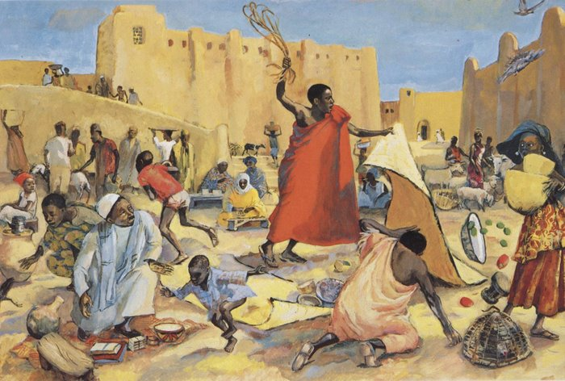
(CCLI License #1552544)

Recording crew:
Glenora Wright
Iran Trenkel
Jeff and Leslie Ward
Jim and Pam Hardenbrook

