Payette and Fruitland United Methodist Churches
January 24, 2021
Third Sunday after Epiphany

Prelude: “Carillon Toccata” by Douglas Wagner

Welcome

Interlude: “Rock of Ages” arranged by Thomas Hastings

Welcoming the neighborhood to worship
Call To Worship:
Reading from Psalm 62
Leader: Truly my soul finds rest in God; my salvation comes from him.
People: Truly he is my rock and my salvation; he is my fortress, I will never be shaken.
Leader: Trust in him at all times, you people; pour out your hearts to him, for God is our refuge.
All: One thing God has spoken, two things I have heard; “Power belongs to you, God, and with you, Lord, is unfailing love.”

Calling Song Holy, Holy, Holy TFWS #2007
Holy, holy, holy. My heart, my heart, adores you!
My heart knows how to say to you: You are holy Lord!

Santo, santo, santo, mi corazon te adora!
Mi corazon te sabe decir: Santo eres, Dios!

Unison Invocation
Merciful God, we confess that we have not loved you with our whole heart.
Our faith has been tested and we have stumbled.
Our feet have strayed from the path of Christ and we have wandered from you.
We have put our faith in the loud voices of this world, ignoring your whispers.
Forgive us, we pray.
We do want to follow Jesus, the Christ, in whose name we pray. Amen.

Old Testament Reading Jonah 3:1-5 and 10
Gospel Reading Mark 1:21-28
God’s Word for God’s people
Thanks be to God

Prayers of the People

Hymn More Like You TFWS #2167
More like you, Jesus, more like you.
Fill my heart with your desire to make me more like you.
More like you, Jesus, more like you.
Touch my lips with holy fire and make me more like you.

Message “I Knew It” Jonah 3:1-5 and 10

Commitment Hymn Here I Am Lord UMH #593
I, the Lord of sea and sky, I have heard my people cry.
All who dwell in dark and sin my hand will save.
I who made the stars of night, I will make their darkness bright.
Who will bear my light to them? Whom shall I send?

Refrain
Here I am, Lord. Is it I, Lord?
I have heard you calling in the night.
I will go Lord, if you lead me.
I will hold your people in my heart.

I, the Lord of snow and rain, I have borne my people’s pain.
I have wept for love of them. They turn away.
I will break their hearts of stone, give them hearts for love alone.
I will speak my word to them. Whom shall I send? (Refrain)

I, the Lord of wind and flame, I will tend the poor and lame.
I will set a feast for them. My hand will save.
Finest bread I will provide till their hearts be satisfied.
I will give my life to them. Whom shall I send? (Refrain)

Benediction
May the peace of the Lord Jesus go with you
wherever he may send you.
May he guide you through the wilderness,
protect you through the storm.
May he bring you home rejoicing
at the wonders he has shown you.
May he bring you home rejoicing once again into our doors.

Postlude: “Fanfare for a New Day” by Lani Smith

Recording Crew:

Jim and Pam Hardenbrook

Iran Trenkel

Jeff and Leslie Ward

Lyna Kittleman Wilkins

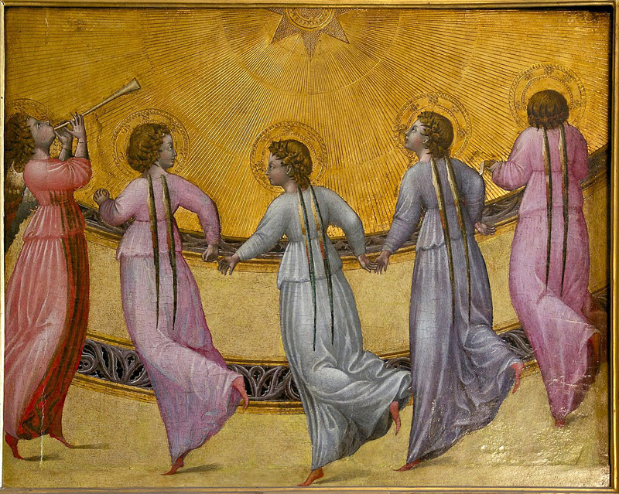

(CCLI License #1552544)

